H.T No
Regulations:
A19

Sreenidhi Institute of Science and Technology
(An Autonomous Institution)
Code No: 7P261 Date: 21-Mar-2023 (FN)

M.Tech I-Year II- Semester External Examination, March/April-2023 (Supplementary)
ARTIFICIAL INTELLIGENCE & DEEP LEARNING (CSE and CS)

Time: 3 Hours Max.Marks:70

Note: a) No additional answer sheets will be provided.
b) All sub-parts of a question must be answered at one place only, otherwise it will not be valued.
c) Missing data can be assumed suitably.
Bloom's Cognitive Levels of Learning (BCLL)

Remember | L1 | Apply | L3 | Evaluate | L5
Understand | L2 | Analyze | L4 | Create | L6

Part - A Max.Marks:20

Answer all QUESTIONS.

 |  | BCLL | CO(s) | Marks
1 | Define Rational Agent. | L1 | CO1 | [2M]
2 | Define alpha cutoff and beta cutoff. | L1 | CO2 | [2M]
3 | Translate the following sentences into formulas in predicate logic  (i) Every student loves some other student.  (ii) There is a student who is loved by every other student. | L5 | CO3 | [2M]
4 | State the Baye’s Rule . | L1 | CO4 | [2M]
5 | What are convolution filters? | L2 | CO5 | [2M]
6 | Write applications of Reinforcement learning. | L1 | CO6 | [2M]
7 | List the properties of planning. | L1 | CO1 | [2M]
8 | What are the basic components of propositional logic? | L1 | CO3 | [2M]
9 | Write the formula to predict number of neurons in CNN required for next layer if window size (W), filter size (F), padding (P) and stride (S) is provided. | L3 | CO5 | [2M]
10 | Mention the problem characteristics. | L2 | CO1 | [2M]

Part – B Max.Marks:50
ANSWER ANY FIVE QUESTIONS. EACH QUESTION CARRIES 10 MARKS.

 |  |  | BCLL | CO(s) | Marks
11. | a) | What is the structure of Intelligent Agent? Discuss the various types of agent programs. | L2 | CO1 | [5M]
 | b) | Write short notes on classical planning problem. | L1 | CO1 | [5M]
12. | a) | Write and explain A* Algorithm with an example. “A* is admissible” justify the statement. | L2 | CO2 | [5M]
 | b) | Explain Alpha-Beta pruning with suitable example. | L1 | CO2 | [5M]
13. | a) | Explain the predicate logic representation with a suitable example. | L2 | CO3 | [5M]
 | b) | Discuss issues in Knowledge representation. | L1 | CO3 | [5M]
14. | a) | In the following cyclic MDP calculate Q(p,A) where C(a)=4 , C(b)=9 C(c)=1  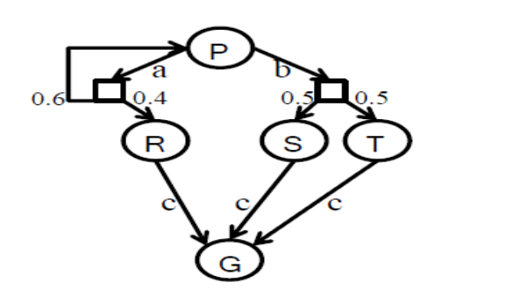 | L5 | CO4 | [5M]
 | b) | Describe the role of probability theory in AI. | L1 | CO4 | [5M]
15. | a) | Write about shortcomings of feature selection. | L1 | CO5 | [5M]
 | b) | Draw and explain the architecture diagram of CNN. | L2 | CO5 | [5M]
16. | a) | What is Markov Decision Process? Explain with an example. | L1 | CO6 | [5M]
 | b) | Write about Q Learning. | L2 | CO6 | [5M]
17. | a) | Discuss types of environments. | L1 | CO1 | [4M]
 | b) | What are constraint satisfaction problems? | L2 | CO2 | [3M]
 | c) | What is padding in CNN? | L2 | CO5 | [3M]

-- 00 -- 00 –

